

INDORE INSTITUTE OF SCIENCE AND

TECHNOLOGY

Department of Mechanical Engineering

Internal Combustion Engines Me-501

Lab Manual

Experiment no :- 03

Study of Fuel Injection System in SI Engine.

Submitted by :

Pradhumn Chandrawat

0829ME181018

INDORE INSTITUTE OF SCIENCE AND TECHNOLOGY

I.C. ENGINE LAB

EXPERIMENT NO. 03

Objective: Study of Fuel Injection System in SI Engine.

Introduction

Spark-ignition engines normally use volatile liquid fuels. Preparation of fuel-air mixture is done outside the engine cylinder and formation of a homogeneous mixture is normally not completed in the inlet manifold.

There are Two types of fuel injection system used in S.I Engine.

1. Carburetion

2.Multi Point Fuel Injection System

1. Carburetion

Spark-ignition engines normally use volatile liquid fuels. Preparation of fuel-air mixture is done outside the engine cylinder and formation of a homogeneous mixture is normally not completed in the inlet manifold. Fuel droplets, which remain in suspension, continue to evaporate and mix with air even during suction and compression processes. The process of mixture preparation is extremely important for spark-ignition engines. The purpose of carburetion is to provide a combustible mixture of fuel and air in the required quantity and quality for efficient operation of the engine under all conditions.

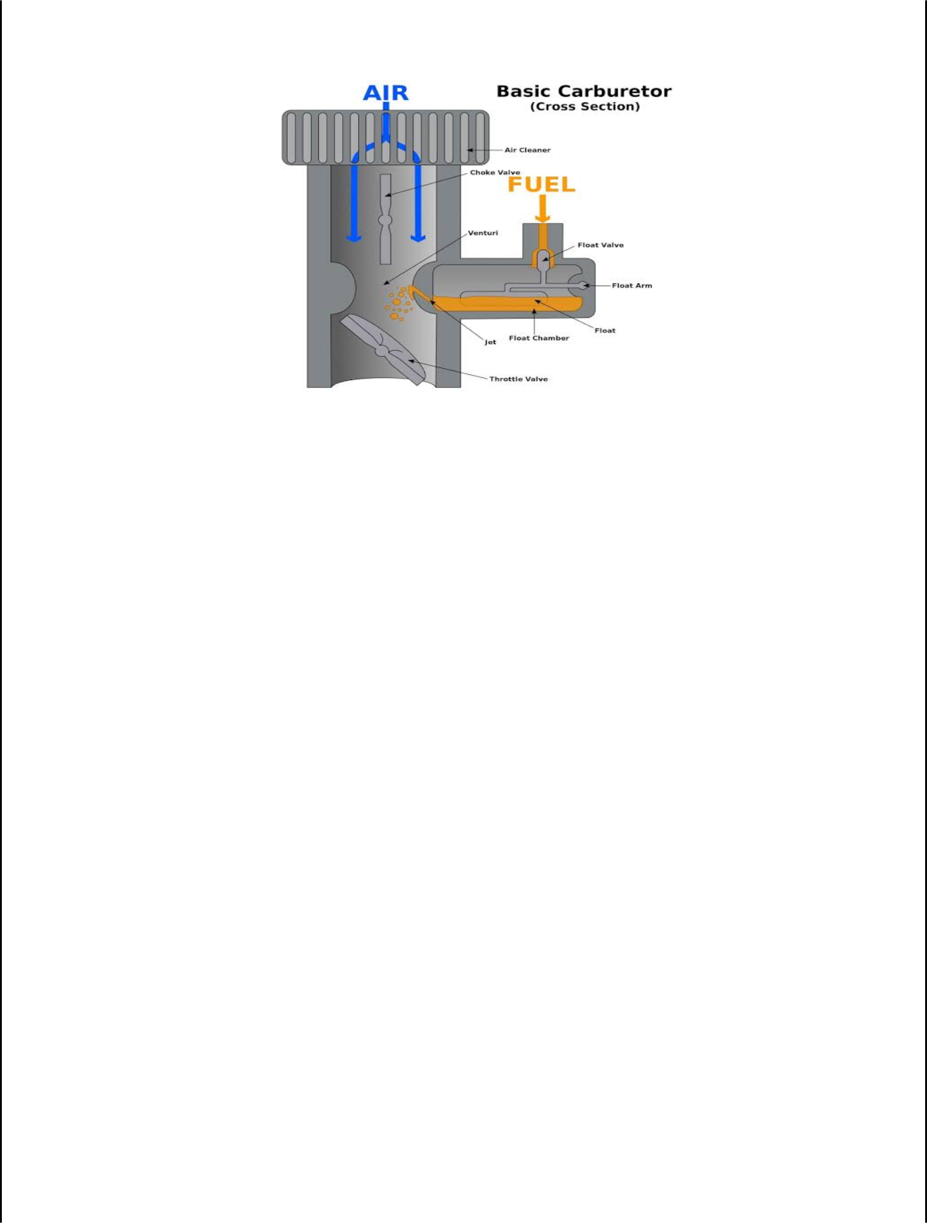

Definition of Carburetion;

The process of formation of a combustible fuel-air mixture by mixing the proper amount of fuel with air before admission to engine cylinder is called carburetion and the device which does this job is called a carburettor.

Definition of Carburettor;

The carburetor is a device used for atomizing and vaporizing the fuel and mixing it with the air in varying proportions to suit the changing operating conditions of vehicle engines.

Principle of Carburetion

Both air and gasoline are drawn through the carburettor and into the engine cylinders by the suction created by the downward movement of the piston. This suction is due to an increase in the volume of the cylinder and a consequent decrease in the gas pressure in this chamber.

It is the difference in pressure between the atmosphere and cylinder that causes the air to flow into the chamber. In the carburettor, air passing into the combustion chamber picks up discharged from a tube. This tube has a fine orifice called carburettor jet that is exposed to the air path.

The rate at which fuel is discharged into the air depends on the pressure difference or pressure head between the float chamber and the throat of the venturi and on the area of the outlet of the tube. In order that the fuel drawn from the nozzle may be thoroughly atomized, the suction effect must be strong and the nozzle outlet comparatively small. In order to produce a strong suction, the pipe in the carburettor carrying air to the engine is made to have a restriction. At this restriction called throat due to increase in velocity of flow, a suction effect is created. The restriction is made in the form of a venturi to minimize throttling losses.

The end of the fuel jet is located at the venturi or throat of the carburettor. The geometry of venturi tube is as shown in Fig.16.6. It has a narrower path at the centre so that the flow area through which the air must pass is considerably reduced. As the same amount of air must pass through every point in the tube, its velocity will be greatest at the narrowest point. The smaller the area, the greater will be the velocity of the air, and thereby the suction is proportionately increased

As mentioned earlier, the opening of the fuel discharge jet is usually loped where the suction is maximum. Normally, this is just below the narrowest section of the venturi tube. The spray of gasoline from the nozzle and the air entering through the venturi tube are mixed together in this region and a combustible mixture is formed which passes through the intake manifold into the cylinders. Most of the fuel gets atomized and simultaneously a

small part will be vaporized. Increased air velocity at the throat of the venturi helps he rate of evaporation of fuel. The difficulty of obtaining a mixture of sufficiently high fuel vapour-air ratio for efficient starting of the engine and for uniform fuel-air ratio indifferent cylinders (in case of multi cylinder engine) cannot be fully met by the increased air velocity alone at the venturi throat.

Factors Affecting Carburetion

Of the various factors, the process of carburetion is influenced by i. The engine speed

- The vaporization characteristics of the fuel
- The temperature of the incoming air and
- The design of the carburettor

Advantages of Carburettor Feeding Engine

It’s a simple and low cost fuel feeding system both for two stroke & four stroke motorcycle engine.

Simplicity and being mechanical its maintenance and repair is possible and quite easy.
It can be tweaked easily according to user need and environment condition.
Being mechanical device it responds uniquely every possible position & action of throttle.
Frequent respond against revving and over raving is very common character and advantage of a carburettor feeding system. That’s why it very widely suitable for off road and dirt bikes.
Fuel contamination issue can be over looked in carburettor engine though it hampers the performance.
Very much suitable fuel feeding system for low cost & low capacity motorcycle engines.

Disadvantages of Carburettor Feeding Engine

Its fuel feeding quantity is not précised as it allows feeding flow according to the suction speed & quantity of the air by the combustion chamber. Fuel economy is considerably very low in carburettor engine.

In carburettor fuel feeding system the engine cold start is a big issue.
Lean & rich mixture often becomes hassle in carburettor engine.
Due to inefficient combustion the emission is significantly high in carburettor engine.
In some case engine gets vibration and spark plug fouling issue is very common.

Multi Point Fuel Injection (MPFI)

The MPFI is a system or method of injecting fuel into internal combustion engine through multi ports situated on intake valve of each cylinder. It delivers an exact quantity of fuel in each cylinder at the right time. There are three types of MPFI systems – Batched, Simultaneous and Sequential.

In the batched MPFI system fuel is injected to the groups or batches of the cylinders without bringing their intake stroke together. In the simultaneous system,

fuel is inserted to all cylinders at the same time, while the sequential system injection is timed to overlap with intake stroke of each cylinder.

MPFI includes a fuel pressure regulator, fuel injectors, cylinders, pressure spring and a control diaphragm. It uses multiple individual injectors to insert fuel in each cylinder through intake port situated upstream of cylinder’s intake value. The fuel pressure regulator, connected to the fuel rail by means of an inlet and outlet, directs the flow of the fuel. While the control diaphragm and pressure spring controls the outlet valve opening and the amount of fuel that can return. The pressure in the intake manifold significantly changes with the engine speed and load.

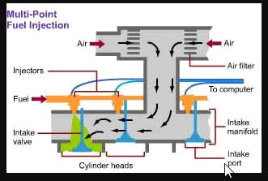
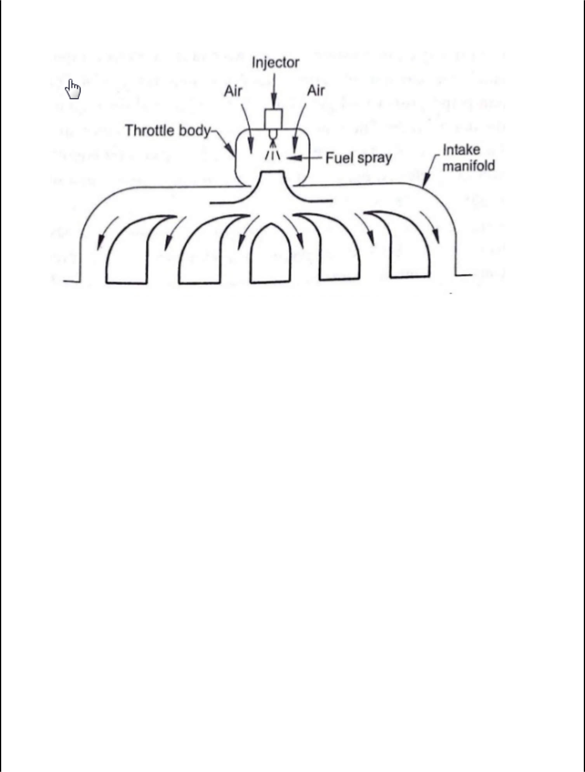

Advantages of multi point fuel injection system

The multi-point fuel injection technology improves fuel efficiency of the vehicles. MPFI uses individual fuel injector for each cylinder, thus there is no gas wastage over time. It reduces the fuel consumption and makes the vehicle more efficient and economical.
The vehicles with MPFI auto-mobile technology have lower carbon emissions than a few decades old vehicles. It reduces the emission of the hazardous chemicals or smoke, released when fuel is burned. The more precise fuel delivery cleans the exhaust and produces less toxic by products. Therefore, the engine and the air remain cleaner.
MPFI system improves the engine performance. It atomizes the air in small tube instead additional air intake, and enhances the cylinder-to-cylinder fuel distribution that aid to the engine performance.
It encourages distribution of more uniform air-fuel mixture to each cylinder that reduces the power difference developed in individual cylinder.
The MPFI auto-mobile technology improves the engine response during sudden acceleration and deceleration.
The MPFI engines vibrate less and don’t require to be cranked twice or thrice in cold weather.
It improves functionality and durability of the engine components.
The MPFI system encourages effective fuel utilization and distribution. .

DISADVANTAGE OF MPFi SYSTEM :-

Repairing of fuel injectors is not easy as compared to carburettor technology.

This system usually have shorter life.

If there will ECU failure the engine will seize.

Possible vapour lock in the steel fuel lines above the engine, making it difficult to start a hot engine

